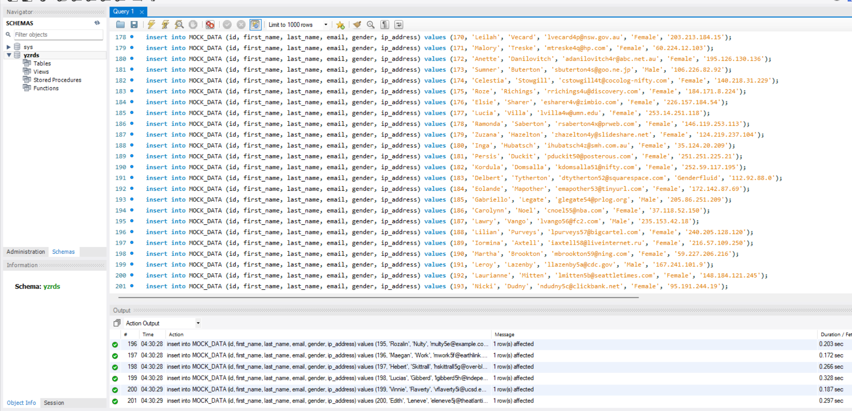

Select male   
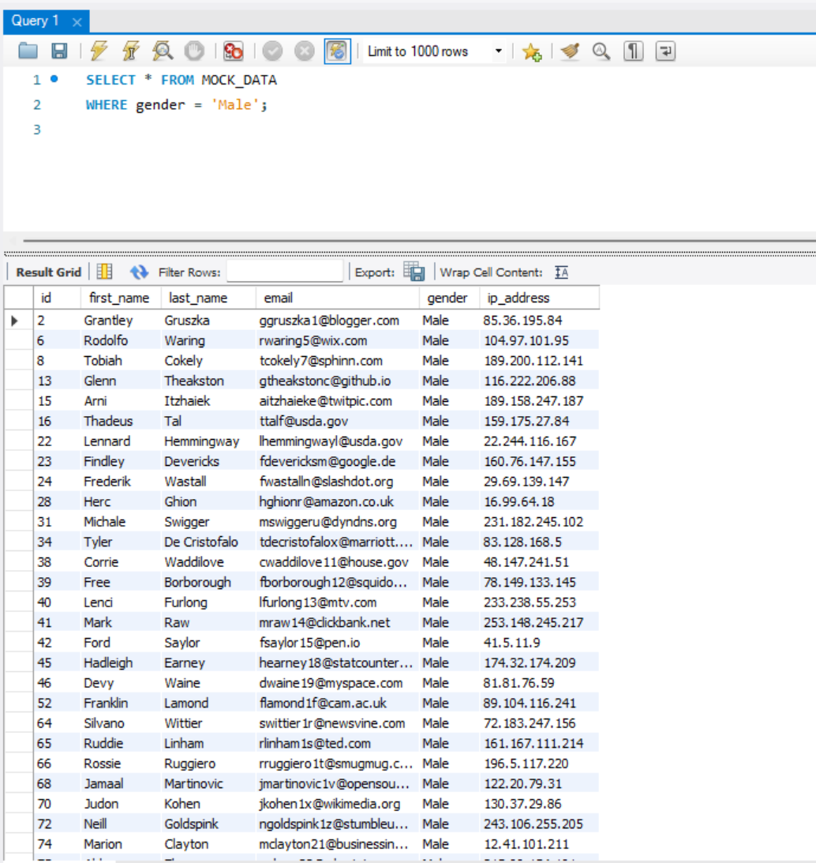

Select last name smith

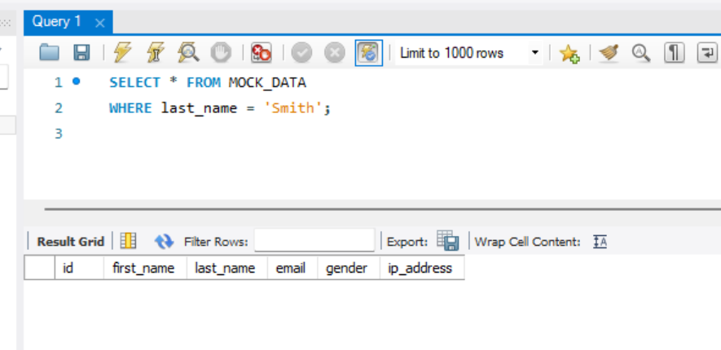

Group the gender and count them

